**Alien Banjo Attackers from Space – Manual**

“Alien Banjo Attacks from Space” or “ABAS” for short. In this action packed space shooter the player must control the “Battleship Accordion” in its fight to save the planet from an attack of deadly space banjos.The player must shoot the banjos using musical notes and prevent them from touching the player and reach the bottom of the screen. If any of the banjos touches the player they lose a life. After the player loses three lives the game is over.

**Gameplay features**

There are three different types of banjo: Plain Banjo, Hunter Banjo and the Deadly Banjo.



Plain Banjo: This alien moves from left to right. When it reaches the edge of the screen it drops down and then moves back. If it reaches the bottom of the screen the game is over. It takes one hit to destroy and is worth 10 points. If it collides with the player it is destroyed and the player loses a life.



Hunter Banjo: The Hunter Banjo will behave like a Plain Banjo for five seconds and will then move towards the player. If it reaches the bottom of the screen the game is over. It takes one hit to destroy and is worth 20 points. If it collides with the player it is destroyed and the player loses a life.



Deadly Banjo: This moves towards the player as soon as it appears. It moves faster than the Hunter Banjo. The Deadly Banjo will fire notes which are aimed at the position of the player at the time the note is fired. It takes two hits to destroy and is worth 50 points. If it collides with the player it is destroyed and the player loses a life.

**Gameplay Tutorial**

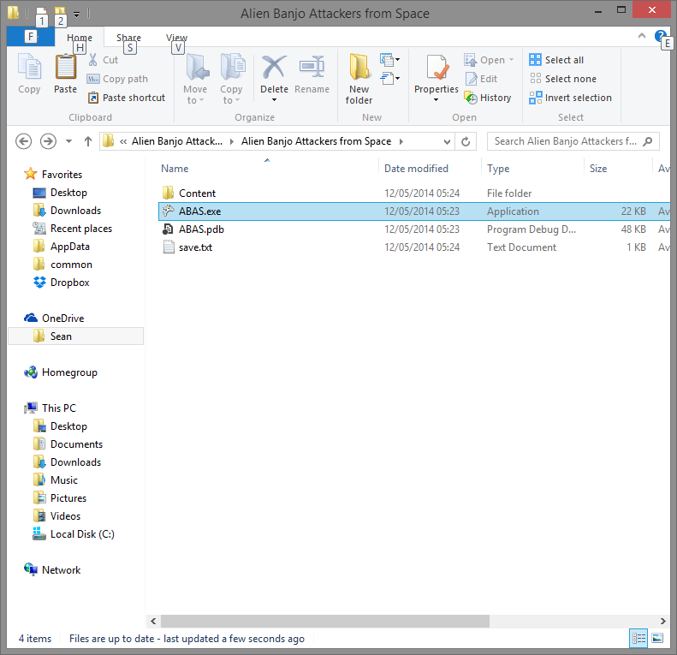

To start the game double click on the “ABAS.exe”. Once you have started the game you will jump right into the action!

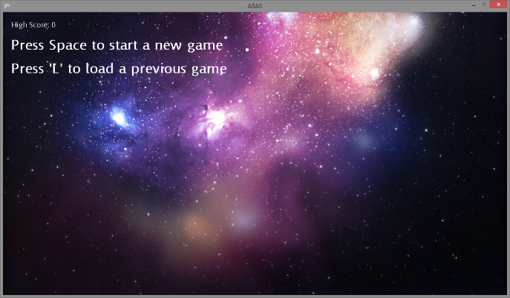Once in the main menu you can start a new game (press ‘space bar’), load a previously saved game (press ‘L’ key) and exit the game (press the ‘Escape’ key).

Note: If a previous save file does not exist then the game will start a new game

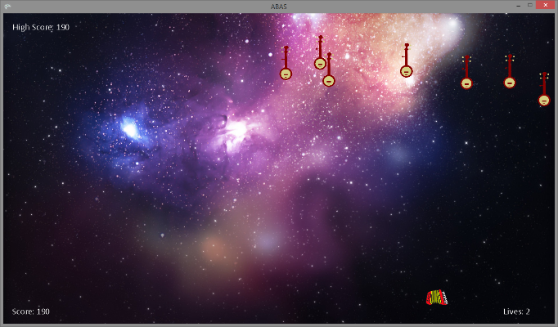

Once in-game you can save / pause the game at any point by pressing the ‘P’ key.

Pressing the left and right arrow keys will move the Battleship Accordion accordingly. Pressing space bar will fire notes at the Alien Banjos!

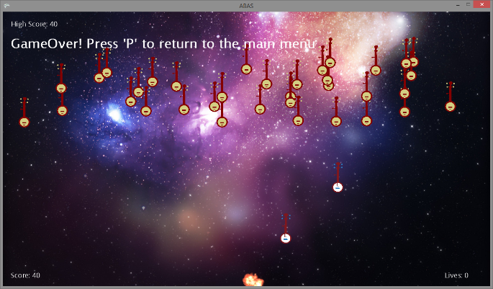After you have been defeated the game over screen will show – prompting you to press the ‘P’ key.

Good luck!